**Global Food Production Trends & Analysis a comprehensive study from 1961–2023 Using Power BI Desktop**

**This is the dataset according to our project**

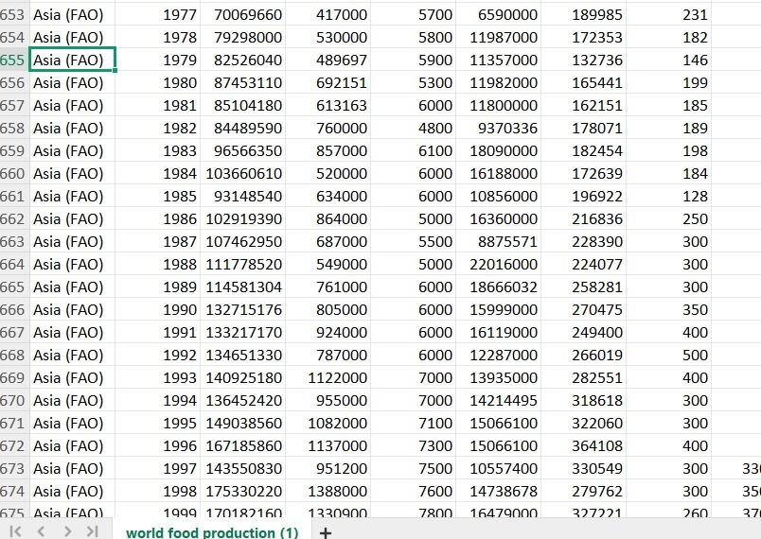

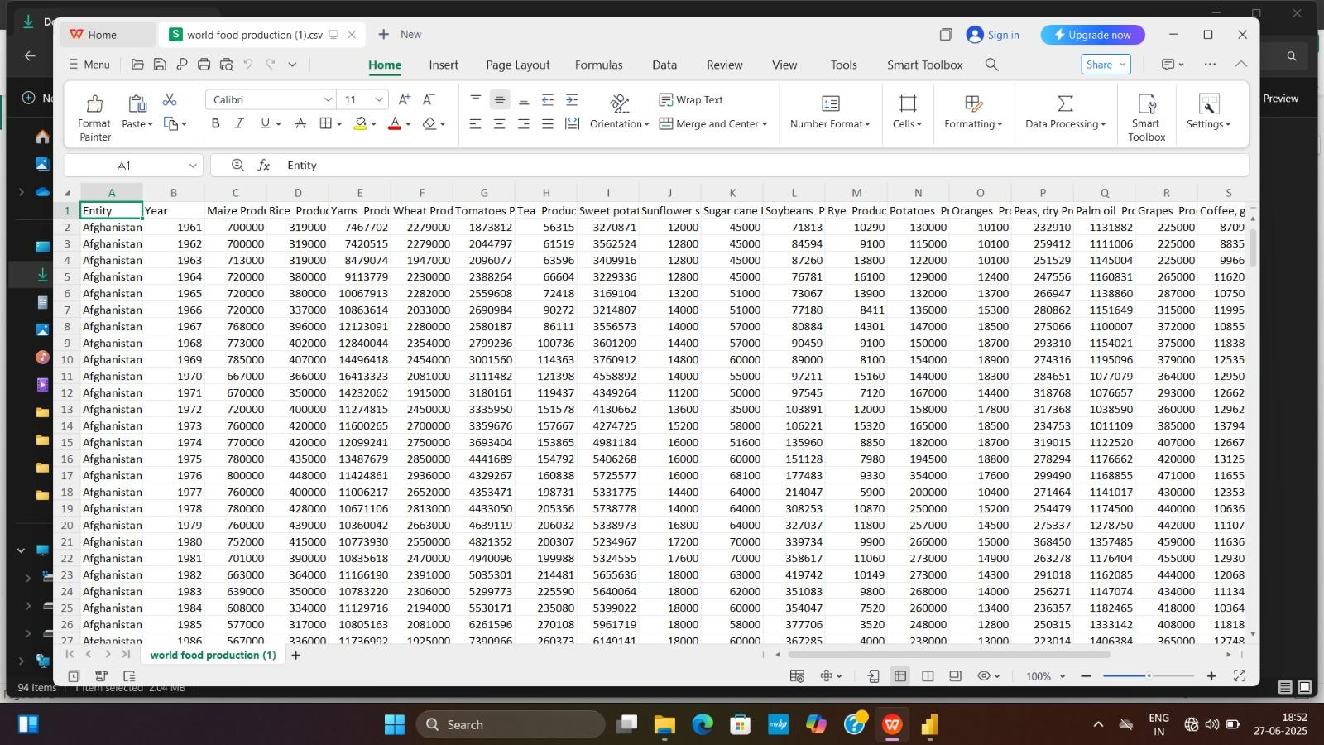

🔷 Overview Page

Title: A Dashboard Page – Global Overview (1961 to 2023)

Main Components:

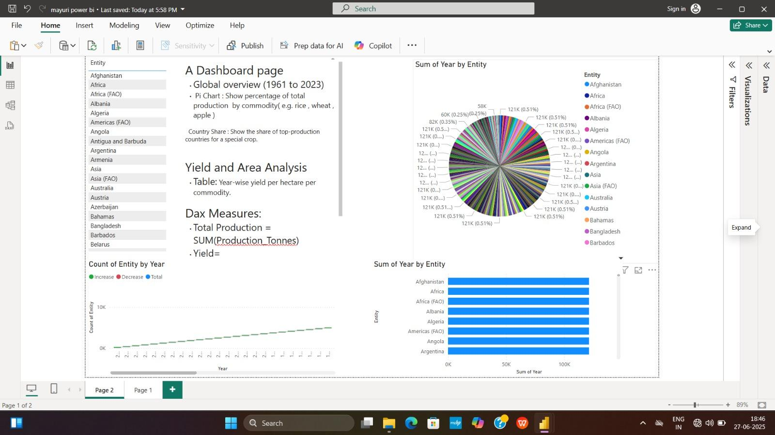

Pie Chart: Displays the percentage share of total production by commodity (e.g., rice, wheat, maize, apple).

Country Share Visual: Identifies top-producing countries for a selected crop.

Bar Chart: “Sum of Year by Entity” shows total years of data available for each entity (e.g., Afghanistan, Asia, Africa).

Line Graph: “Count of Entity by Year” tracks global participation over time.

📈 Key DAX Measures Used

Total Production:

Total Production = SUM('Production Tonnes')

Yield:

(Assumed formula, you can update based on available area data)

Yield = DIVIDE(SUM('Production Tonnes'), SUM('Area Harvested'), 0)

📊 Page 2 – Deep Dive Analysis

Entity Filtering: Slicer for selecting countries/regions.

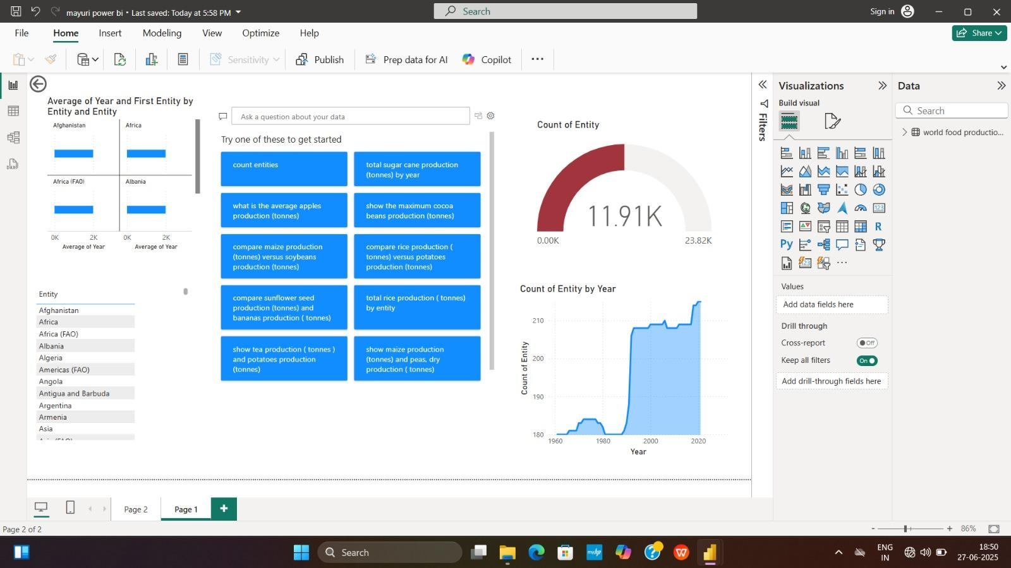

Gauge Chart: Shows total count of unique entries (currently ~11.91K).

Line Area Chart: Tracks number of entities reporting production data from 1961 to 2023.

Bar Chart: Shows average year and first reporting year per entity.

💡 Insight Examples

Asia (FAO) has consistently shown increasing total production in all major commodities over decades.

Data Spikes: Notable increases in data count after 1990, likely due to improved data collection or inclusion of more countries/entities.

Commodity Comparison:

Power BI Q&A suggests queries like:

“Compare maize production vs. soybean production”

“Show average apples production”

“Total sugarcane production by year”

✅ Benefits of This Power BI Dashboard

Dynamic filtering by country, commodity, or year.

Interactive visuals make it easy to identify trends, compare crops, and track historical data.

Smart analytics through DAX and AI visual Q&A help uncover hidden insights.

📌 Suggestions for Enhancement

Add area harvested or yield per hectare visualizations.

Use forecasting visuals to predict future trends.

Incorporate map visualizations for spatial production insights.

Add tooltips with percentage change YoY or highlight anomalies.